
Business Question and Visualization Report

Date | 18 August 2026
Team ID | --
Project Name | India's Agricultural Crop Production Analysis (1997–2021)
Maximum Marks | 5 Marks

Visualization development refers to the process of creating graphical representations of data to facilitate understanding, analysis, and decision-making. The goal is to transform complex datasets into visual formats that are easy to interpret, enabling users to gain insights and make informed decisions. Visualization development involves selecting appropriate visual elements, designing layouts, and using interactive features to enhance the user experience. This process is commonly associated with data visualization tools and platforms, and it plays a crucial role in business intelligence, analytics, and reporting
Business Questions and Visualisation
The process involves defining specific business questions to guide the creation of meaningful and actionable visualizations in Tableau. Well-framed questions help in identifying key metrics, selecting relevant data, and building visualisation that provide insights.

1.What is the total agricultural production trend in India from 1997–2021?

Visualization: Column/Bar Chart – Year wise total agricultural production (1997–2021)

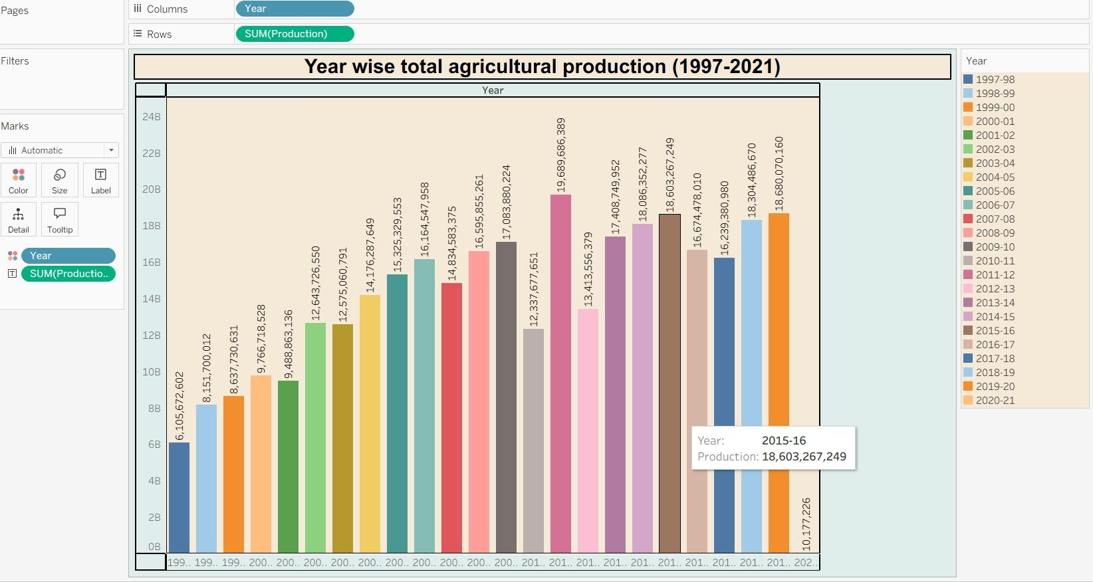
2. Which season contributes the highest share of agricultural production?

Visualization: Pie Chart – Season wise agricultural production share

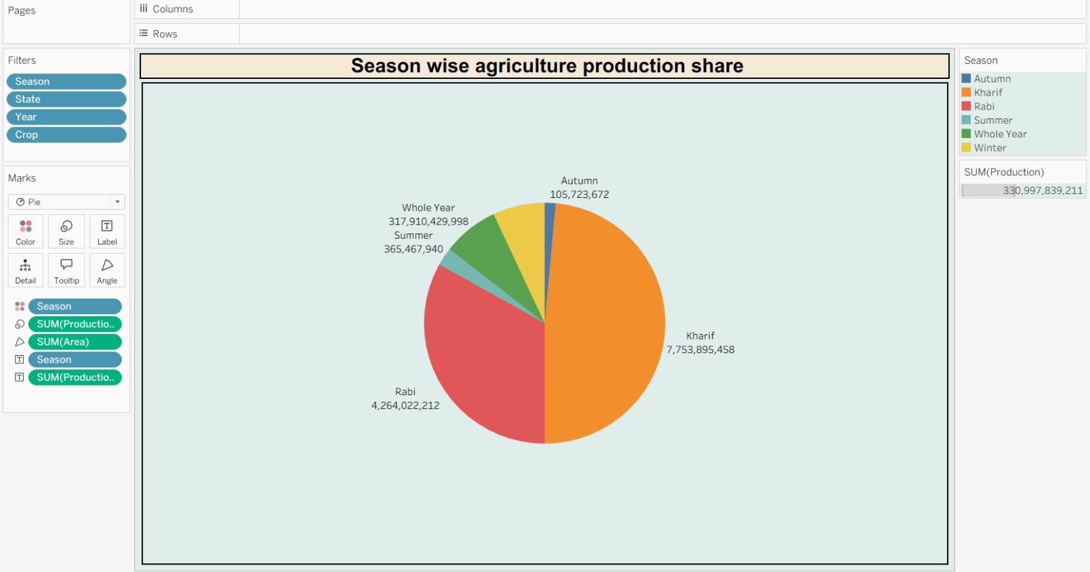

3. How is agricultural production distributed by production unit?

Visualization: Donut Chart – Production distribution by unit type

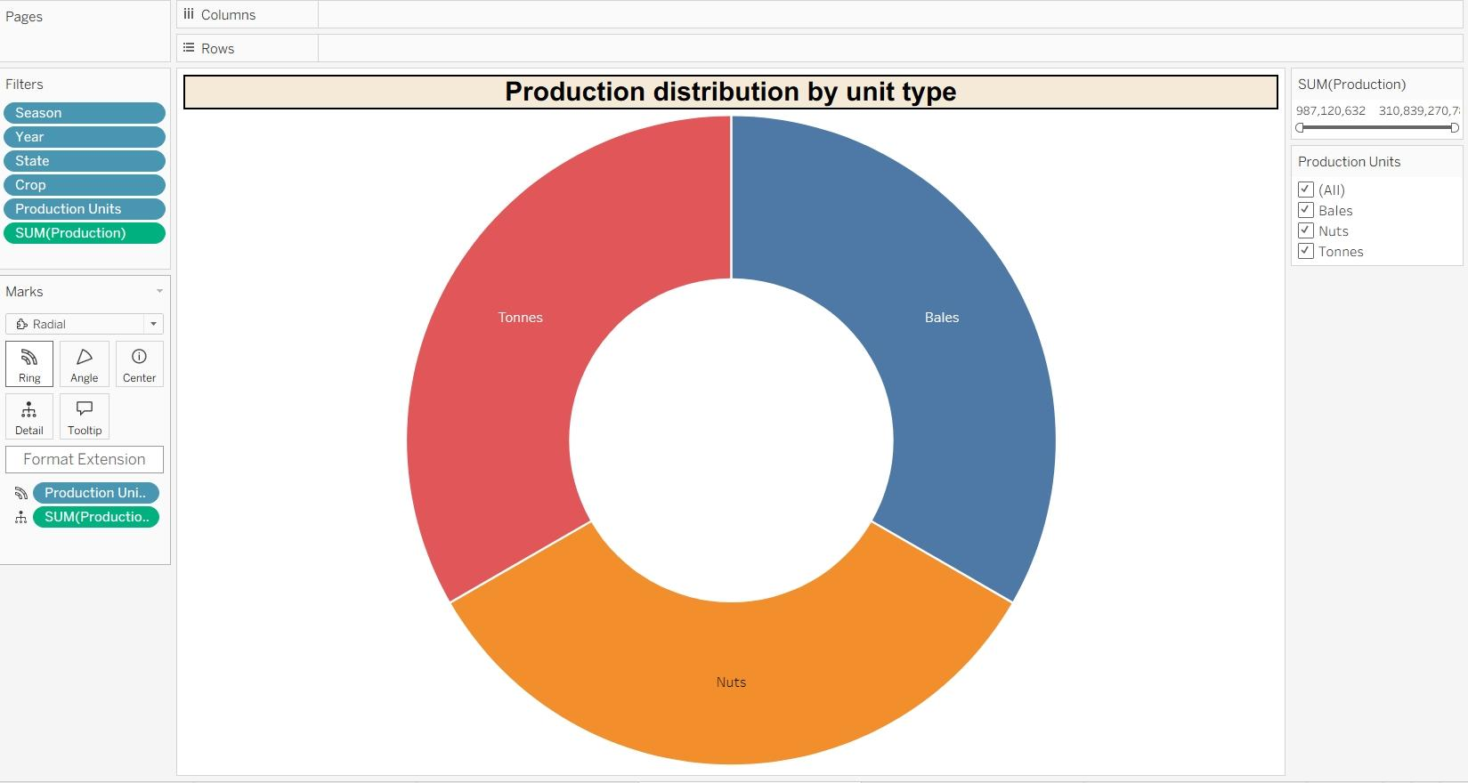

4. Which states are the leading contributors to agricultural production?
Visualization: Bar Chart – Leading states by agricultural production
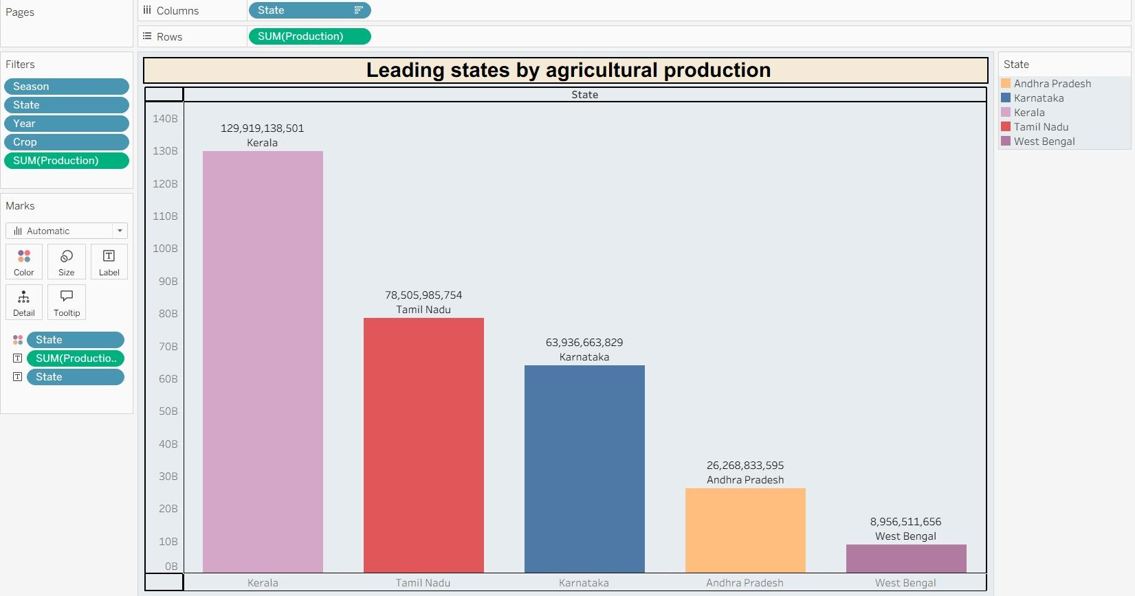

5. Which states have the largest cultivated agricultural area?
Visualization: Bar Chart – State wise cultivated Area comparison.

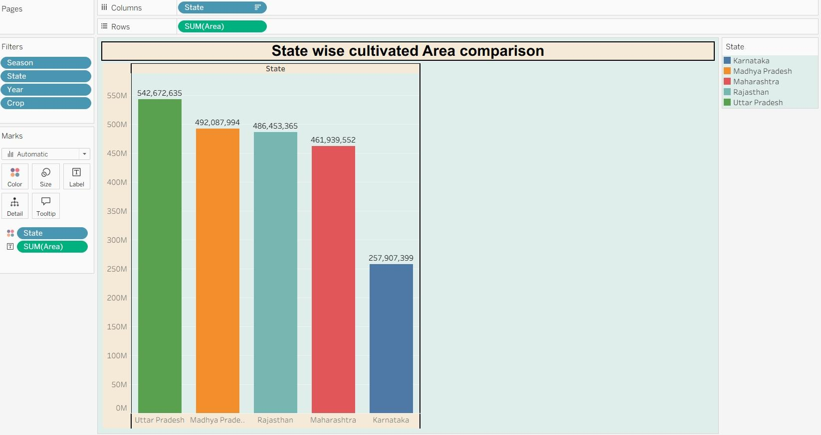

6. Which crops occupy the largest cultivated area?
Visualization: Horizontal Bar Chart – Comparison of cultivated area by crop.

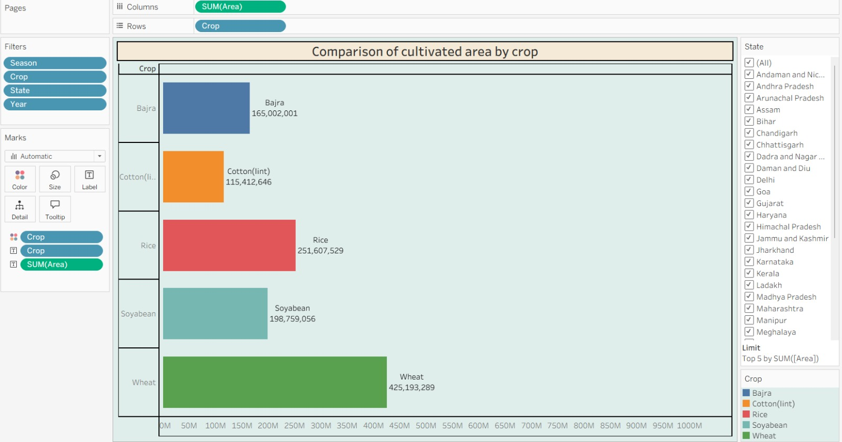

7. How is agricultural production geographically distributed across Indian states?
Visualization: Map – State-Wise Agricultural Production Distribution (India)
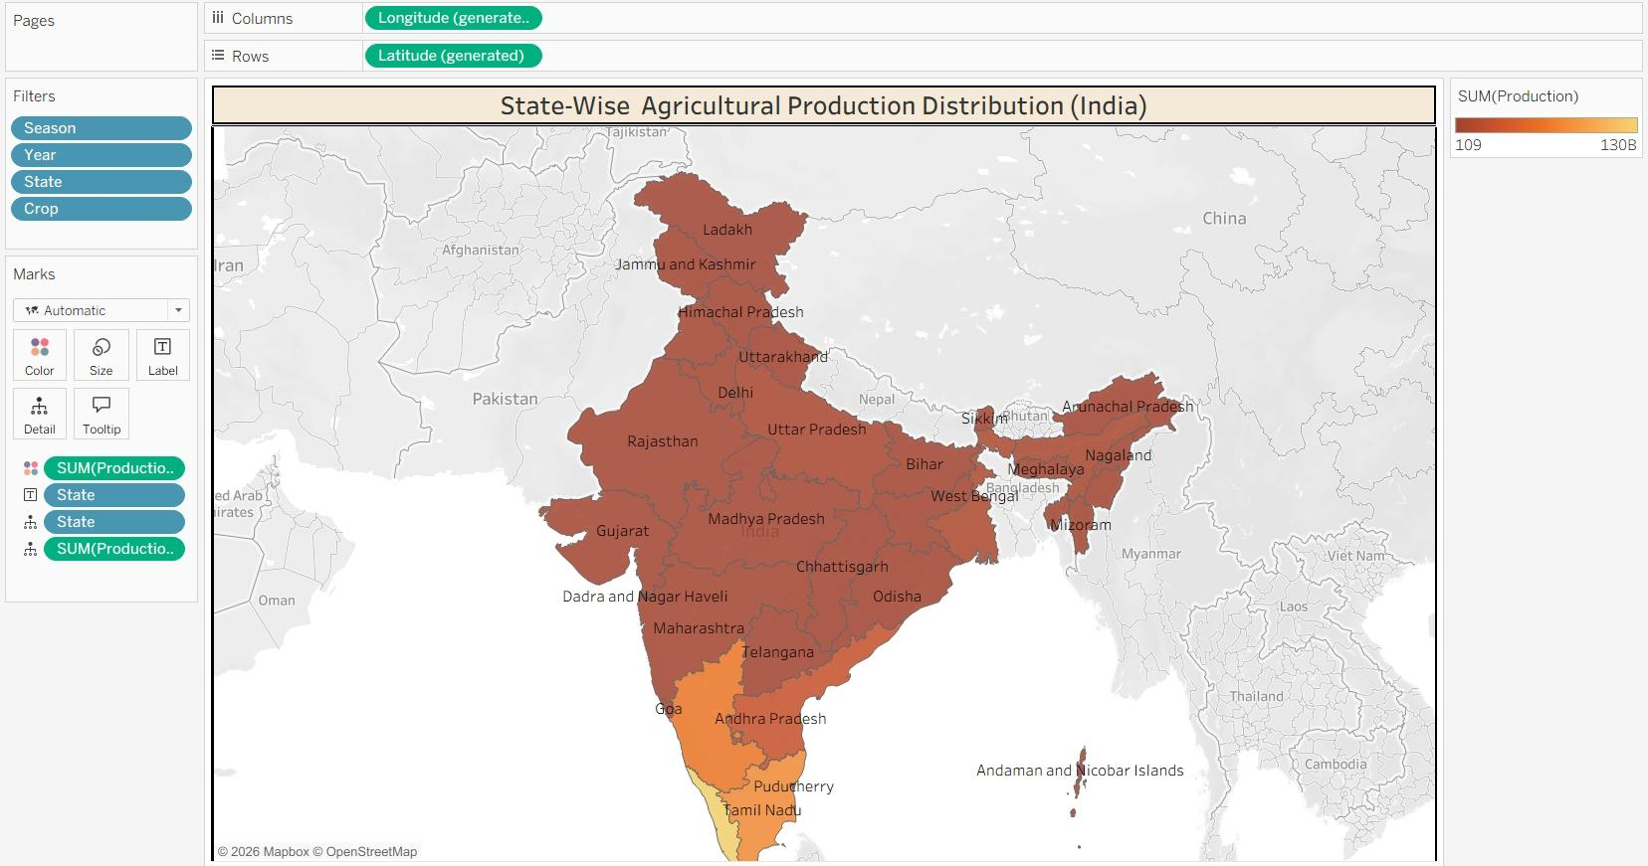

8. What is the trend of agricultural yield from 1997–2021?
Visualization: Line Chart – Trend of Agricultural Yield (1997–2021)
